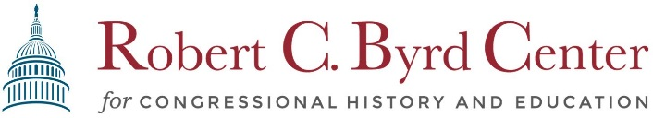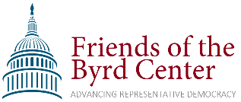
Fundraiser Sponsorship
Event Description: On Saturday June 11, 2022 at 6:00 pm, the Friends of the Byrd Center are sponsoring a lawn concert fundraiser with musicians Johnny Staats and Robert Shafer. The event will include a pig roast barbeque dinner with vegetarian options and will be held on a private property outdoors. More information is available at
byrdcenter.org/summer-fundraiser-2022.
Designation for Funds Raised: After covering expenses for the evening, all proceeds raised from ticket sales and sponsorships will fund the civics education initiatives of the Robert C. Byrd Center for Congressional History and Education, located on the campus of Shepherd University. A private, non-profit, non-partisan organization, the Byrd Center conducts an annual Teacher Institute providing training in civics for over 150 West Virginia educators, offers internships to Shepherd University students, and provides free public programs to the Shepherd campus and Shepherdstown community. More information may be found at www.byrdcenter.org/about-us.
Levels of Sponsorship:
Benefits | $500.00 | $1,000.00 | $1,500.00 | $2,000
Pre-Event Web & Email Recognition | • | • | • | •
Verbal Recognition at Event | • | • | • | •
Display of Business/Organization Logo at Event on Banners | • | •  +stage banner | •  +stage banner | •  +stage banner
2-Complimentary Tickets for Event |  |  | • | •
Featured in Press Releases |  |  |  | •
How to Donate: Donations can be made electronically by visiting our website
byrdcenter.org/summer-fundraiser-2022 and selecting your level of sponsorship.
You may also donate via check, addressed to “The Byrd Center” and writing
“Summer 2022 Fundraiser” on the memo line. Checks may be sent to:
Robert C. Byrd Center for Congressional History and Education
ATTN: Jody Brumage
PO Box 5000 Shepherd University
Shepherdstown, WV 25443

