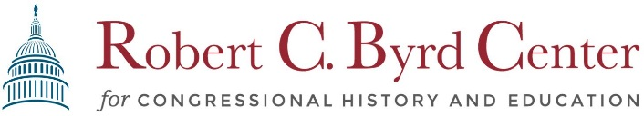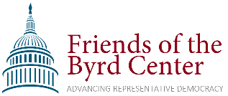
Fundraiser Sponsorship
Event Description: On Saturday June 10, 2023, the Friends of the Byrd Center are sponsoring a lawn concert fundraiser featuring Mountain Stage Pianist Bob Thompson and Shepherd faculty musicians. The event will include food trucks and dessert and will be held outdoors on a private property. More information is available at byrdcenter.org/summer-fundraiser-2023.
Designation for Funds Raised: After covering expenses for the evening, all proceeds raised from ticket sales and sponsorships will fund the civics education initiatives of the Robert C. Byrd Center for Congressional History and Education, located on the campus of Shepherd University. A private, non-profit, non-partisan organization, the Byrd Center conducts a variety of programs in civics education including an annual Teacher Institute, internships to Shepherd University students, and free public programs that reach a wider regional audience.
More information may be found at www.byrdcenter.org
Levels of Sponsorship:
Benefits | $500.00 | $1,000.00 | $1,500.00 | $2,000
Pre-Event Website & Email Recognition | • | • | • | •
Verbal Recognition at Event | • | • | • | •
Display of Business/Organization Logo at Event on Banners | • | •  +stage banner | •  +stage banner | •  +stage banner
Linked logo on website |  | • | • | •
2-Complimentary Tickets for Event |  |  | • | •
Featured in Press Releases |  |  |  | •
How to Donate: Donations can be made electronically by visiting our website
www.byrdcenter.org/tickets-and-sponsorship and selecting your level of sponsorship.
You may also donate via check, addressed to “The Byrd Center” and writing
“Summer 2023 Fundraiser sponsorship” on the memo line. Checks may be sent to:
Robert C. Byrd Center for Congressional History and Education
ATTN: Elizabeth Ricketts
PO Box 5000 Shepherd University
Shepherdstown, WV 25443

Monday, May 22, 2023 is the deadline for submitting sponsorship materials.

